**SIMPLE STATEMENT - Coding Dojo Costa Rica**

**Scholarship**

I, Sofía Esquivel Grosser, declare that I have the minimum level of English required to participate in this program.

My English level will allow me to read, write and talk in that language during the bootcamp.

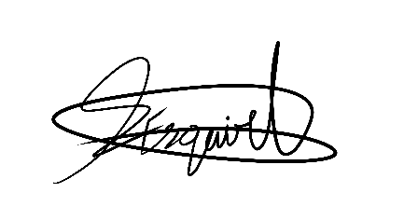

_________________ Sofía Esquivel Grosser

Signature Complete Name

113950812_________

National ID Number